

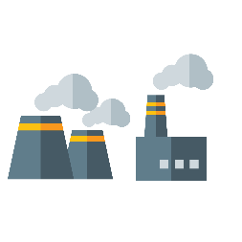

Copyright Geothermal Engineering ltd 2020

**GEOTHERMAL ENGINEERING LIMITED**

1) Can you name 3 types of renewable energy sources?

1. 2. 3.

2) What renewable energy sources have you seen in Cornwall?

3) Can you name a fossil fuel energy?

4) When we burn fossil fuels what gas is released into our atmosphere which contributes to climate change?

5) What does the word geothermal mean? (Match the different parts of the word with their meaning)

6) Can you name a country with volcanoes which uses geothermal energy?

7) Where are the “hottest rocks” in the UK?

8) What is the name of the special rock that produces heat in Cornwall?

9) What is the very deep hole called?

10) What is the shallower hole called?

11) When the heat is delivered to the surface, what do the turbines use to make electricity?

12) As you go deeper underground, what happens to the temperature?

**GEOTHERMAL ENGINEERING LIMITED**

Production well Injection Well

Wind Coal Carbon Dioxide Solar Iceland Cornwall Granite

Oil Steam Hot Gas

EARTH

HEAT

THERMAL

GEO

Label the diagram

Production Well Injection Well Fault

Power plant

How deep is the production well?

How deep is the injection well?